SUMMER 2022 STUDENT PAY PROCESS

It’s almost that time of year to convert our Student Assistants to Summer Bridge. Keep in mind, only convert Students if they are not attending Summer Session.

Departments need to convert student employees into the Bridge Student Assistant (1874) pay class utilizing the effective date of 06/01/2022. *This does not apply to the 1868 pay class, unless there has been a change in citizenship or resident status.

Departments will need to add a new appointment and/or rehire any Student Assistant (1870 or 1868) who will attend Summer Session and work 20 hours per week while school is in session and 40 hours when school is not in session. The effective date must reflect 06/01/2022.

NOTE: All student time for the month of May must be approved on or before the end date of the appointment, but no later than end date of pay period 05/31/2022.

NOW THROUGH AUGUST TIMELINE

Now – June 15 Convert 1870 to 1874 and/or reappoint 1870 and 1868 student assistants.

June 03 Approve all hours worked in the May pay period.

June 16 Any students not reappointed with an expected end date of 05/31/2022 or prior will be terminated.

August 01 Last day of the July pay period and the last day for Bridge Student Assistants (1874).

August 02 - 18 Departments convert Bridge Student Assistants (1874) to the appropriate classification for the Fall Semester with the effective date of 08/02/2022 as either an 1870, 1871, or 1872.

August 05 Approve all hours worked in July pay period.

August 19 ALL active Bridge Student Assistants (1874) will be terminated effective 08/01/2022.

TIME AND LABOR PROCESS
These CSU HR Student Process transactions can be future-dated, but use caution because departments do not have correction mode. If you need assistance with a correction, please contact your respective HR Technician: Ryan @ 8-4709, Anastasia @ 8-1919, Alex @ 8-7173.

For additional information, please reference the process guides on the payroll website: Time Reporting Guides.

Please note: When converting/reappointing a student, please add a row to the current record. Do not create a new record.

Effective Date | Transaction |  | Action/Reason Codes
06/01/2022 | Convert 1870 to 1874. Expected job end date 08/01/2022. |  | DTA/APT
06/01/2022 | Reappoint 1870 or 1868 if enrolled in Summer Session. |  | DTA/APT
06/16/2022 | All active 1870, 1871, 1872 and 1868 with an end date of 05/31/2022 or prior will be automatically terminated. If the employee is going to be working during June/July, they must be appointed in the proper classification effective 06/01/2022. |  | System Generated –  Campus Departments do not need to input terminations.
08/02/2022 | Convert 1874 to 1870, 1871, or 1872 with a new appointment. |  | DTA/APT
*Please note the following:
DTA/APT is used when someone is active. |  | REH/REH is used when someone is inactive (terminated).
If you need assistance with hiring/converting a student, please contact Ryan @ 8-4709, Anastasia @ 8-1919, or Alex @ 8-7173

During June and July, student employees attending Summer Session (1870) may work up to, but not in excess of 20 hours per week when school is in session and 40 hours when school is not in session. Student employees not attending Summer Session (1874) may work up to, but not in excess of 40 hours per week.

Departments are responsible for verifying that individuals classified as an 1870, are attending Summer Session and enrolled in at least six (6) undergraduate units or four (4) graduate units.

Graduating student assistants may work in classification 1874 for one term immediately following graduation. Student Assistants classified as an 1868 will need to contact the International Student Services and Programs for employment eligibility prior to working. Appointments for this classification are terminated at the end of each semester.

The hiring department must properly classify the student employee based on the information in the table below.

Classification | Class Code | Description
Student Assistant | 1870 | US Citizen/Permanent Resident, matriculated Fresno State student registered as, at minimum, a half-time CSU student during Summer Session and working during June/July. Limited to 20 hours per week.
Bridge Student Assistant | 1874 | US Citizen/Permanent Resident, matriculated Fresno State student registered as a CSU student at less than half-time status and working during June/July. Limited to 40 hours per week.
Student Assistant - Nonresident | 1868 | Non-US Citizen/Non-Residents, matriculated Fresno State student employee working during June/July. No change in classification is needed. If the individual is enrolled in the Summer Session, then the individual is limited to 20 hours per week (IRS).

EARNINGS WITHHOLDING INFORMATION FOR STUDENTS

All earnings are subject to Federal and State withholding.

Classification | Class Code | Subject to Federal and State Withholding? | Subject to Social Security (6.2%) and Medicare (FICA) (1.45%) Withholding? ² | Subject to mandatory enrollment in PST (retirement plan) 7.5% rate? ¹
Student Assistant | 1870 | Yes | No | No
Student Assistant - Nonresident | 1868 | Yes but tax treaties need to be considered. | Depends. F, J, M, and Q visa holders are exempt from FICA during their “exempt” years. | No
Bridge Student Assistant | 1874 | Yes | Medicare Only | Yes

¹ Enrollment in the Part-Time, Seasonal, and Temporary (PST) employee retirement program is required. Retirement contributions during employment are available for refund upon separation. Please allow 90 days after separation for the refund. Information and instructions for requesting a refund can be found on the Benefits Services website under: Part Time Retirement Program & PST Fact Sheet. The PST Refund Request Form can be found on the Payroll Services website.
² Earnings as a student assistant in class code 1870 are exempt from Social Security and Medicare (FICA) coverage pursuant to IRS Code Section 3121(b) (10). To remain in compliance with IRS regulations, student employees attending Summer Session are limited to 20 hours per week.

ACCESSING THE DEPARTMENT PAY PERIOD REPORT

Please see the following navaigation path and illustration for Managers and Timekeepers to the Department Pay Period report to access payment information.

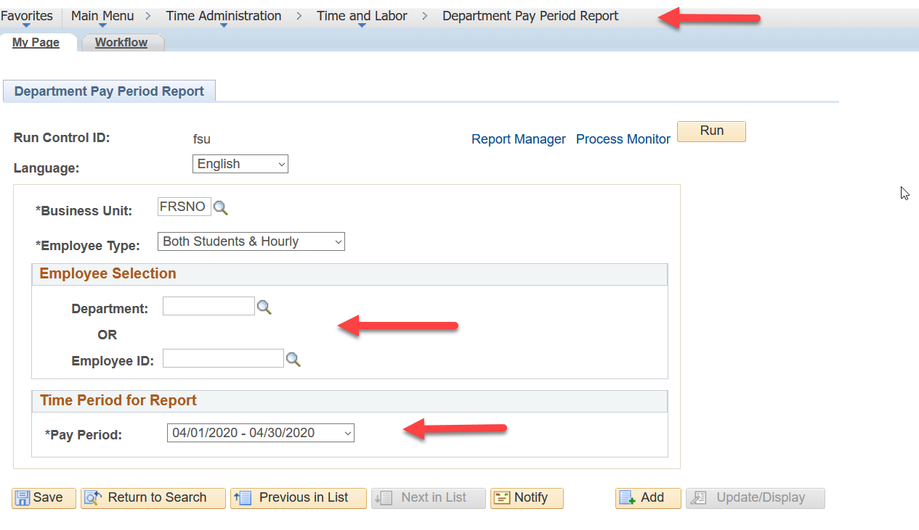

FOR MORE INFORMATION

- FLSA Overview: Fair Labor Standards Act (FLSA)

- Payroll Services Website: Student Assistant Information

- Guidelines for Student Assistants

- Finding Your HR/Payroll Team - Who to contact in HR/Payroll for assistance

- Contact: Jennifer @ 8-5017 Brittanie @ 8-2752 Trisha @ 8-5311 Paula @ 8-5345

